

**Software Requirement Specification**

***Natwest Creditwise Pro***

***Created by:***

**Bipish Goyel**

**Sahil Pandey**

**Karan Goyal**

**Table of Content**

1). Introduction

          1.1 Purpose of this document

          1.2 Scope of this Document

         1.3 Intended Audience and Reading Suggestions

 2). Overall description

          2.1 Product Perspective

          2.2 User Classes and Characteristics

3). Requirements

          3.1 Functional Requirements

          3.2 Non-Functional Requirements

4). Tools and Technologies used

          4.1 Front-End Technologies

          4.2 Back-End Technologies

          4.3 DataBase

          4.4 Security

          4.3.2 Back end (Administrative Tools)

#### 1.Introduction

1.1 Purpose of this document

The purpose of this document is to design an application which provides suggestions to the customers on various products and services based on the marketing model(Pull Strategy) for Natwest Creditwise Pro.

These document will assist in giving a background of how the relevant products will be displayed to the customer as per the market demand and most importantly the credit rating of the customers which will be ascertained based on the age and the yearly income of the customers.

1.2 Scope:

The Natwest Creditwise Pro has various functionalities which will allow the user to have a peek into the various products and services at the best prices guaranteed along with various offers and they can avail the facilities in just a few clicks without any hassle.

1.3 Intended Audience and Reading Suggestions

Natwest Project Manager, Natwest Solutions Developers, Natwest Private LTD Testers, Marketing Staff, Business Users and Technical writers.

2. Overall description

2.1 Product Perspective

The Natwest Creditwise Pro is designed and developed keeping in mind the ease of use and comfortability for the users. It has the required security to protect sensitive personal and financial information and prevent fraud and unauthorized transactions. The Natwest Creditwise Pro has the advanced and future ready technologies that can handle increasing number of users and transactions as the user base grows. The site can be accessed via multiple platforms such as web, mobile, and other hand-held devices.

2.2 User Classes and Characteristics

1.Consumers

2.Business

3.Banks

3.Requirements:

3.1. Functional Requirements

Register & Login: User should be able to Register and login to the System in order to use the services, needs to provide below details.

* Full Name
* Mobile number
* Address
* Age
* Monthly Income
* Expenses
* Email Address
* Password
* Confirm Password

3.2. Non-Functional Requirements

* The Application should be Responsive on all the devices and should have great user experience.
* This needs to have separate front end and back-end.
* The App needs to interact with SQL database for relevant data processing.
* The App needs to support JWT token based authentication while logging in and then only services can be accessed.

4.Tools and Technologies used

4.1. Front-End Technologies

* HTML, CSS, JS
* Bootstrap and MUI for Designing
* React JS

4.2. Back-End Technologies

* Spring Boot – Used to create all the micro services used in this Project
* Rest API

4.3 Database

MySQL – We have used MySQL Database to store the data of the users who will register to use the wallet services

4.4 Security

* JWT Token – Created the JWT token in the backend and used that token to authenticate the users in the frontend.
* The token was stored in the local storage of browser.

Registration and Login Diagramatical Representation.

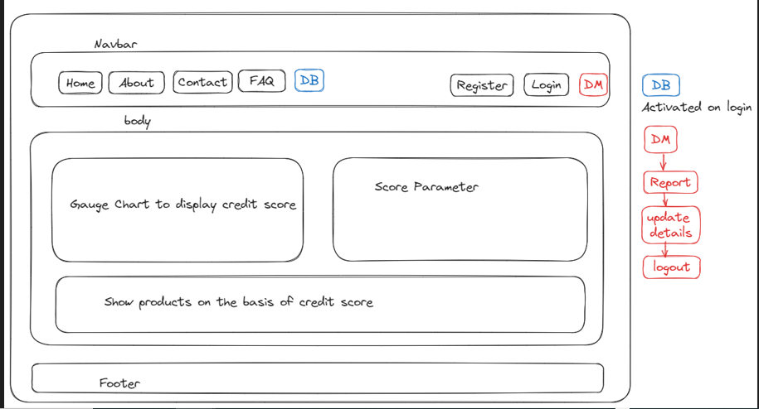

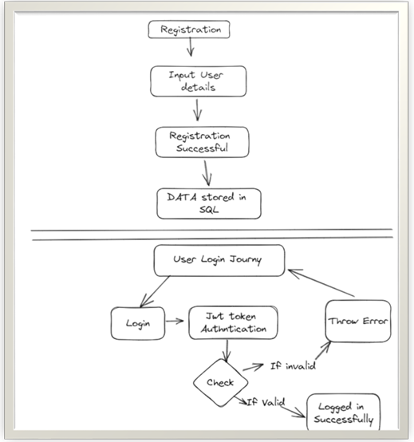

Backend Service Structure for User registration, Rest template (database link with wallet) & Secure JWT token login

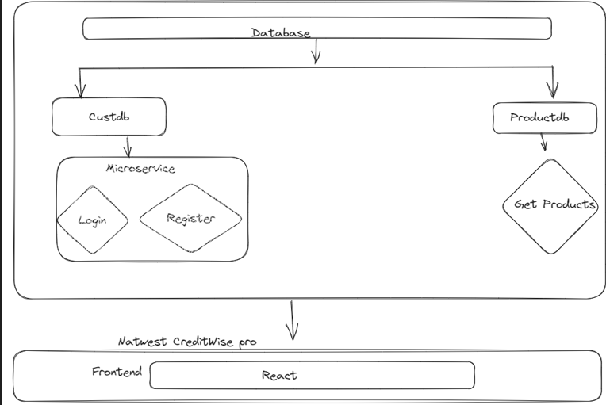

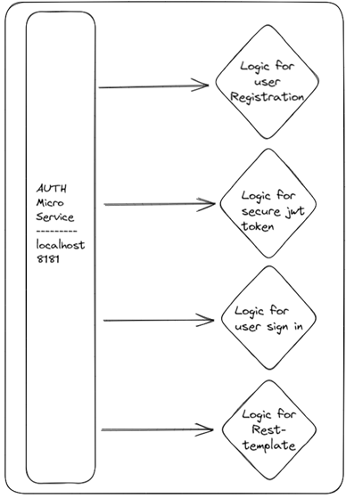

Spring Boot service explanation via diagram

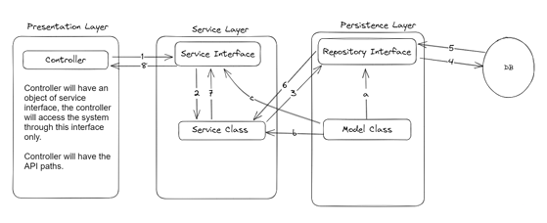

Credit Score and relevant products

